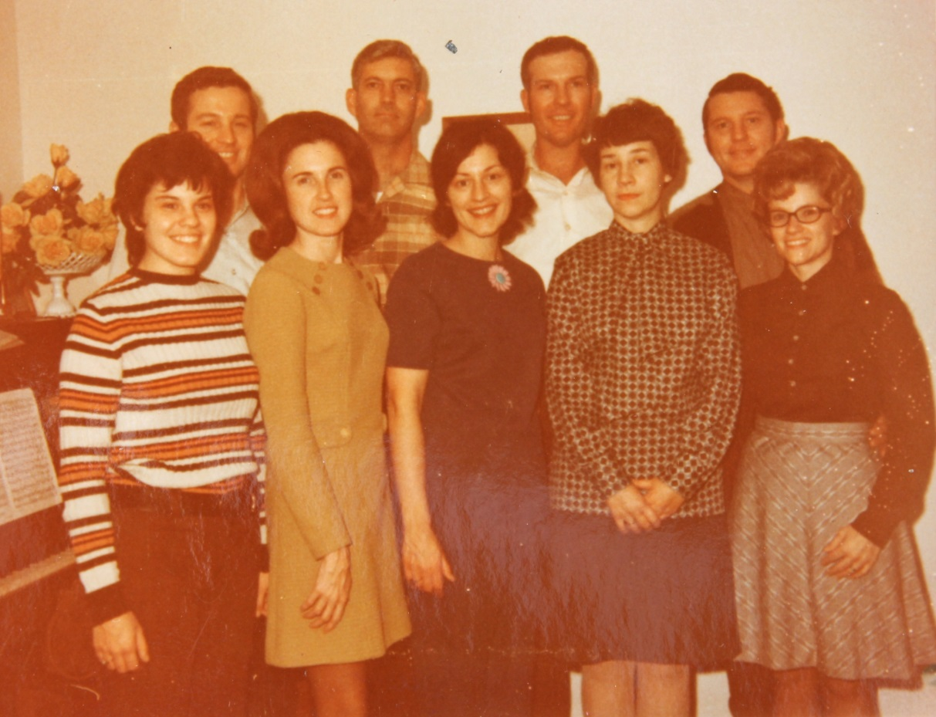

Back row: Mark List, Donald Raasch, Ronald List, David List

Brenda List, Jeanette List, Dorothy List Raasch, Jo Ann Clark List,

Carolyn Huffer List – about 1966 (est.)

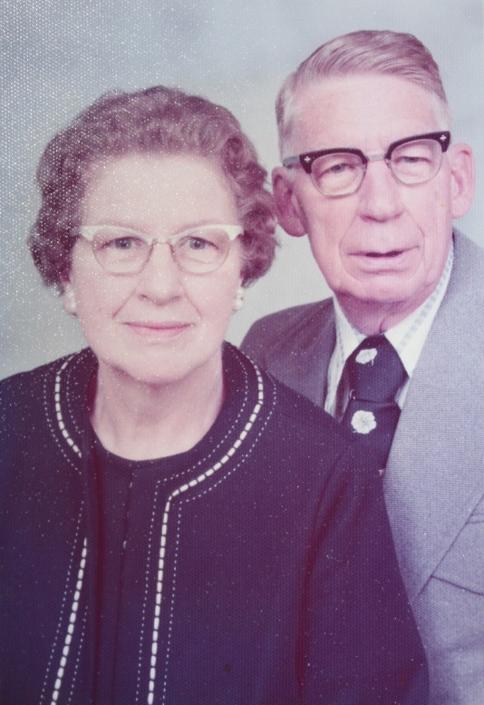

Dorothy Elizabeth Wolfe List & Gordon Ritter Worthen – about 1975 (est.)